How to add a network printer to Mac,Pc How to to a network printer to pc- Before you connect your network please make sure that you have connectivity to your computer with an ethernet cable Step 1- The first thing you need to go is to your printer and test out a configuration page if you need help on how to print a configuration page look at your printer’s service manual Step 2-Now make your way to the add a printer option on the top right side Step 3- When you click on add a printer you will get to screen that says “What type of printer do you want to install? After you see that message click on “Add a network, wireless, or bluetooth printer. Step 4- After you select the printer you want you will arrive to a screen that shows list of printers that are connected. To add the new printer click on the option “The printer that I want isn’t listed?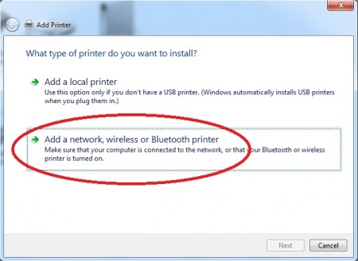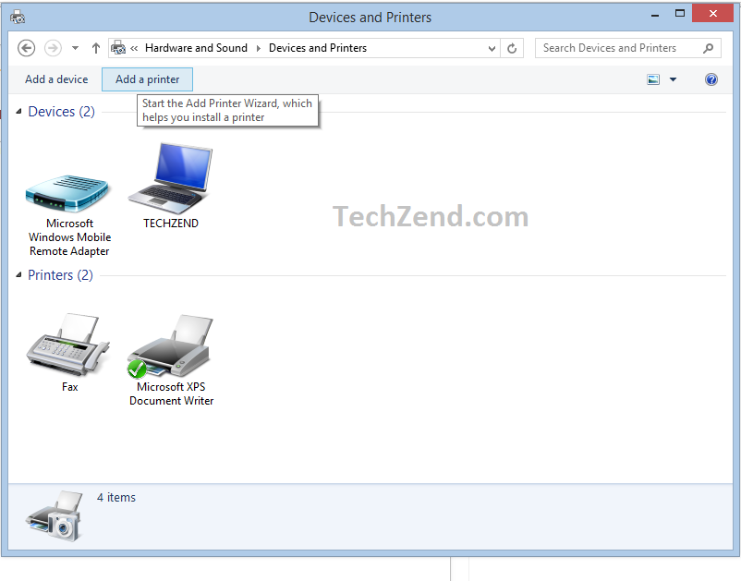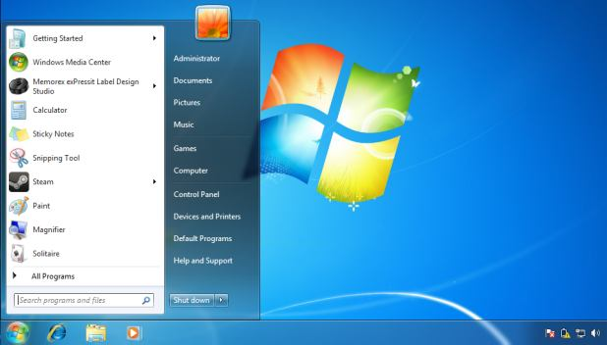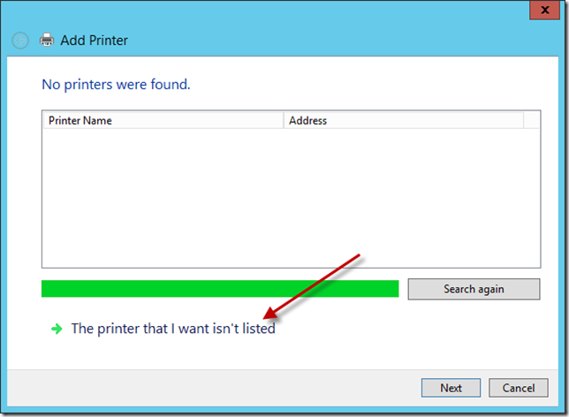

Step 5-After that you will get to a new window that is titled “Find a printer by name or TCP/IP address and you want to click on the option, “find a printer in the directory based on location or feature”. Step 6- Now you will search for the printer that you want to connect to the network by the name, model, or location. Step 7- After you get through finding the printer that you are looking for you will see a confirmation window that says connecting to “Name of your printer” Step 8- After the confirmation window your printer will begin to install as it may take a few minutes. After your printer has been installed make sure print a test page to make sure that you connected to the printer successfully. 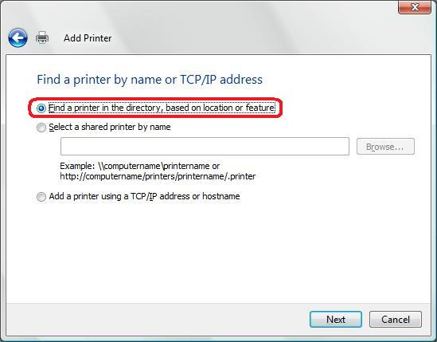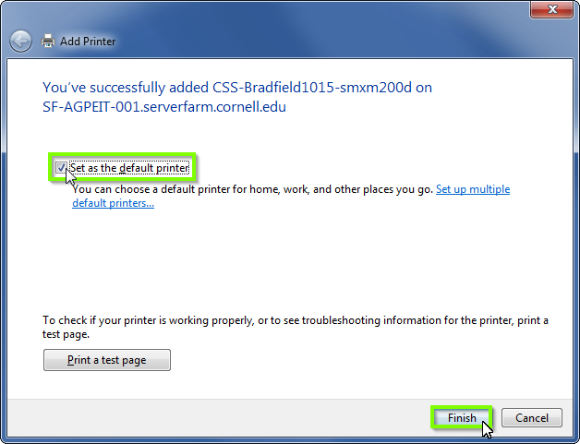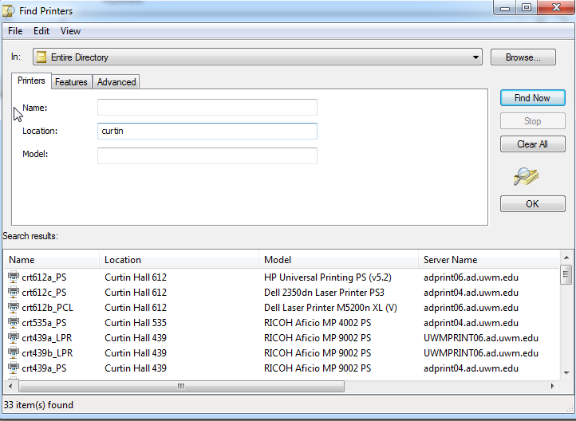

How to add a network printer to a mac Before connecting to a network printer to a mac make sure you are connected to a the network through an ethernet cable . Also in addition print out a configuration test page from your printer Step 1. Go to the apple menu on the top left hand corner and select system preferences Step 2 After clicking on the option System preferences select the option printers and scanners. Step 3 A window will pop up after you select printers and and scanners and what you want to do now is select the “+” icon to add a printer Step 4 After that you will want to type the printer's IP address so click on the IP icon and write down the IP address of your printer. If you don’t know your printer’s IP address look at your configuration page that you printed out in the steps before . Step 5 Make sure that you give a printer a name and after that click add 